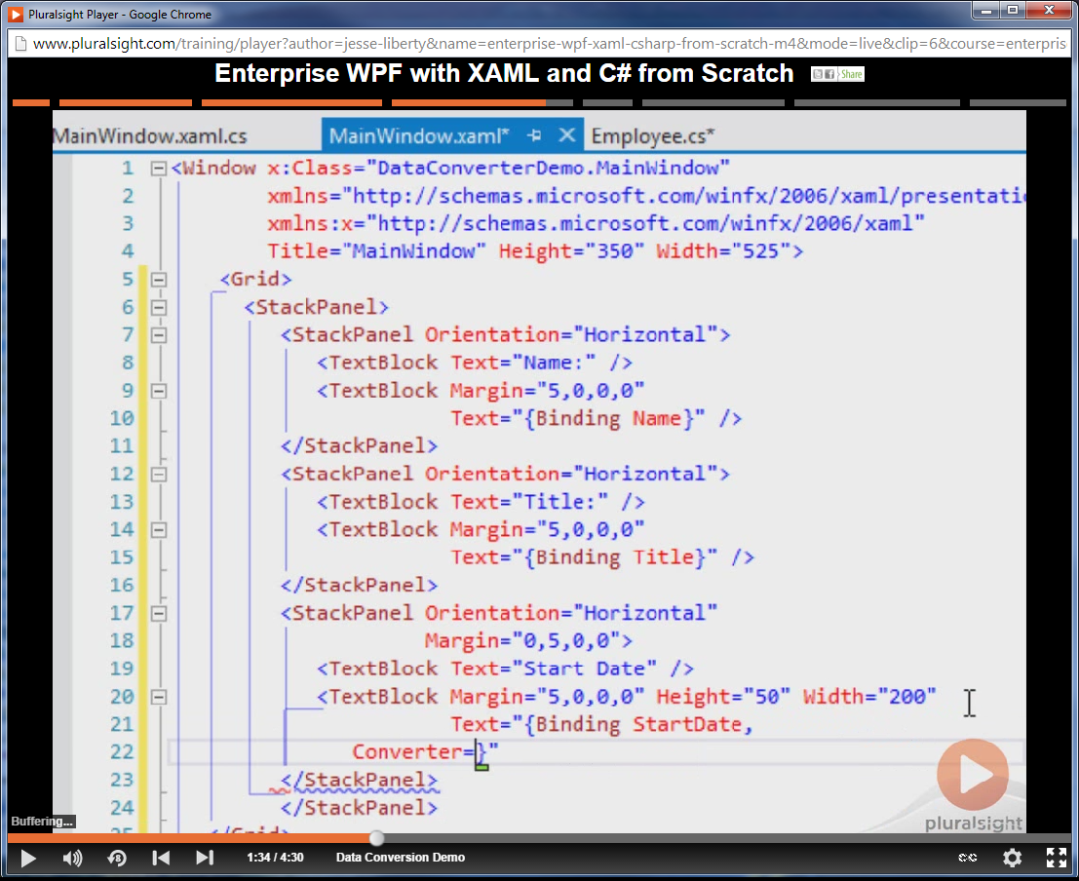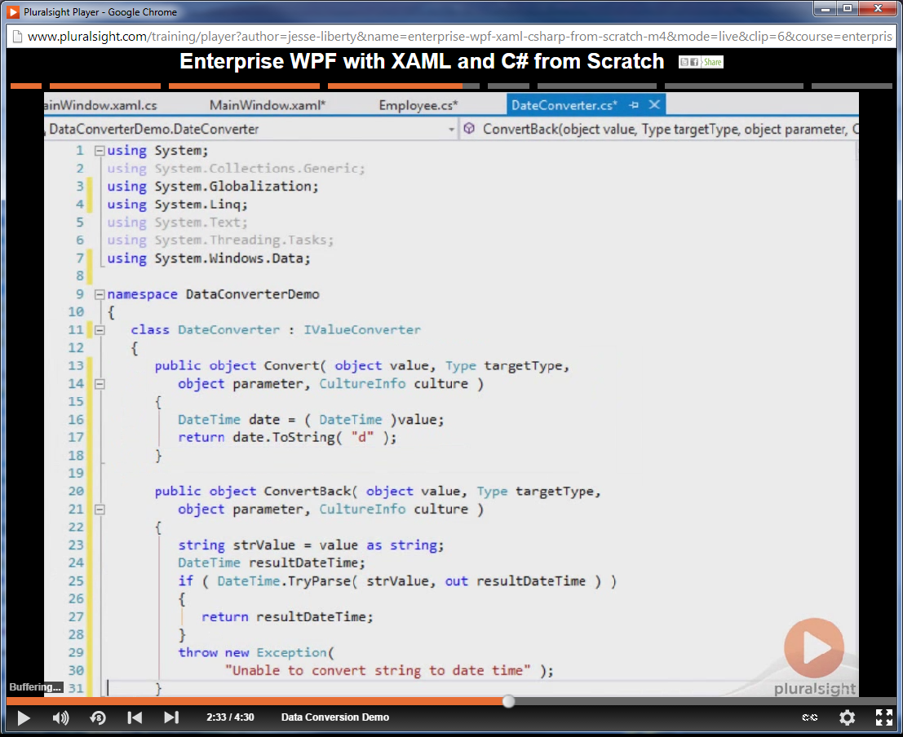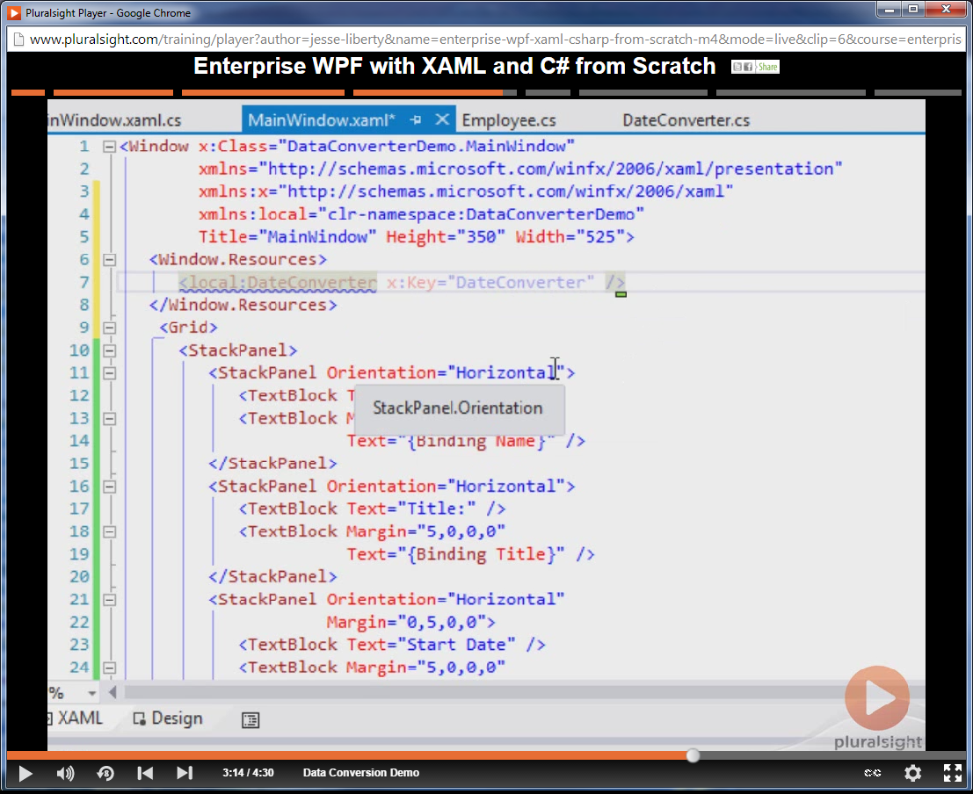

Add Namespace: xmlns:local=”clr-namespace:DataConverterDemo”.
Add the static Window Resource for the DateConverter.
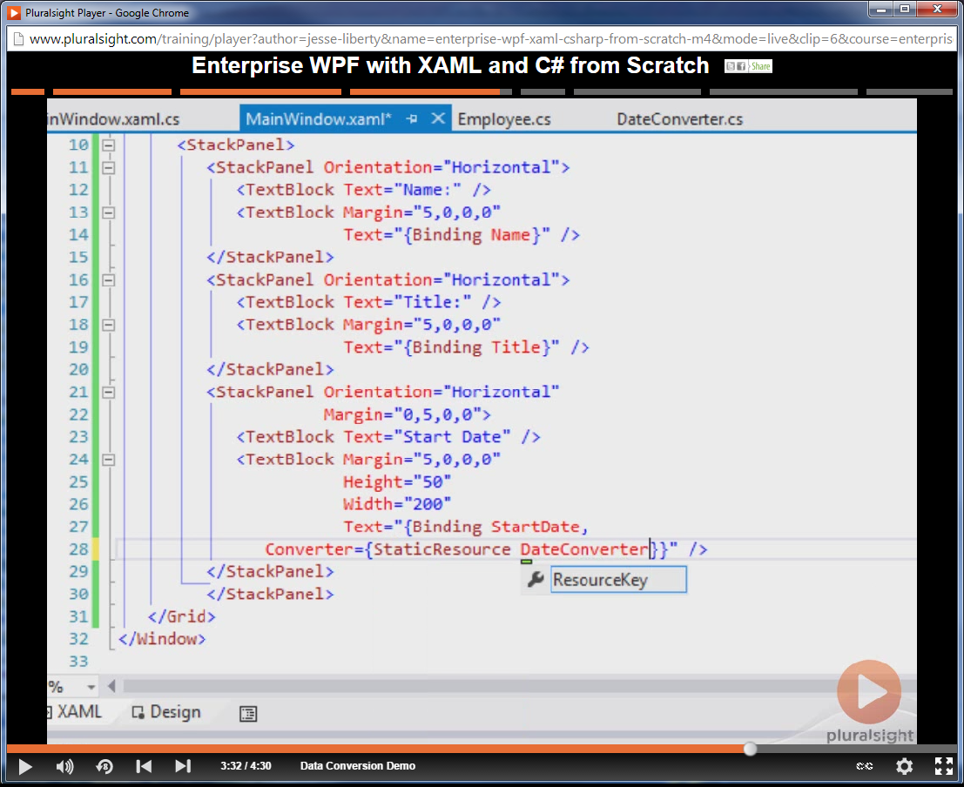

Set the converter equal to the static resource that we just created.

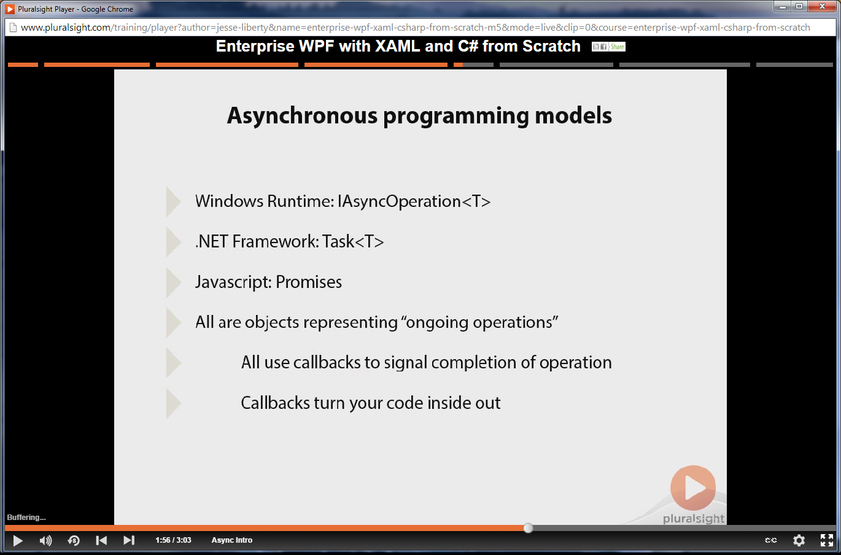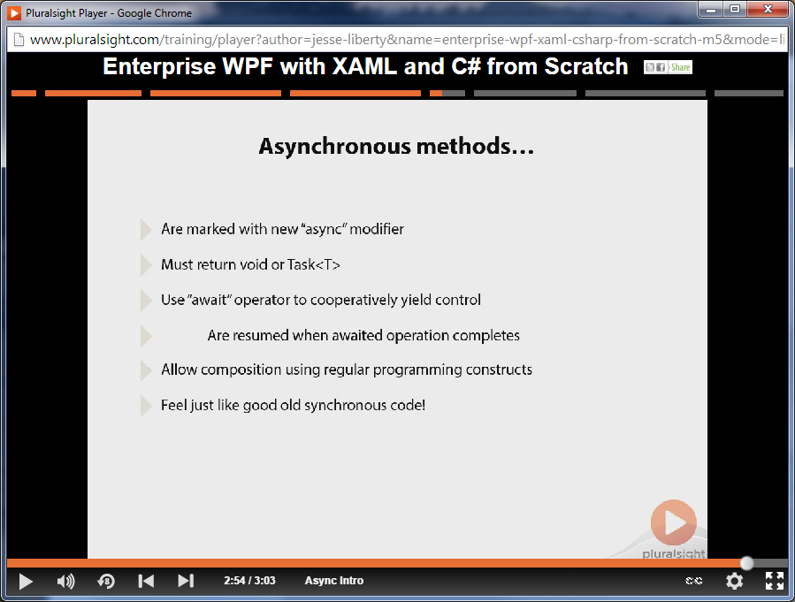

Asynchronous methods automatically transform normal code into a callback state machine.

